**Logistic Regression: Testing**

To test your model, you would run a subset of your data, known as the validation set, on your model to get predictions. The predictions are the outputs of the sigmoid function. If the output is ≥=0.5≥=0.5, you would assign it to a positive class. Otherwise, you would assign it to a negative class.

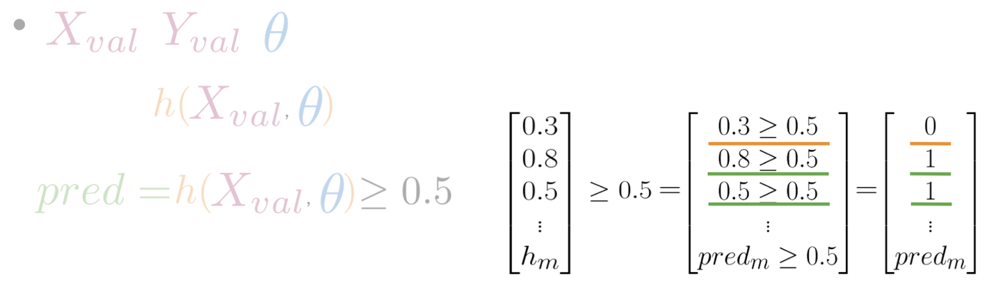

In the video, I briefly mentioned X*X* validation. In reality, given your X*X* data you would usually split it into three components. Xtrain,Xval,Xtest*Xtrain*​,*Xval*​,*Xtest*​. The distribution usually varies depending on the size of your data set. However, an 80,10,1080,10,10 split usually works fine.

To compute accuracy, you solve the following equation:



In other words, you go over all your training examples, m*m* of them, and then for every prediction, if it was right you add a one. You then divide by m*m*.